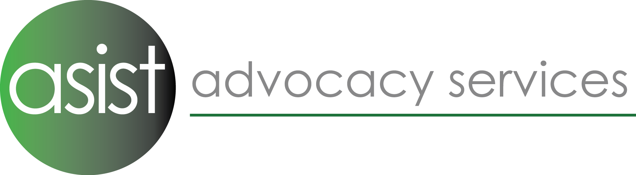

Advocacy Administrator

Job description

Responsible to: Service Manager

Overall Purpose: To support the Advocacy Hub service delivery model by providing administrative assistance to the team; ensuring our triage response continues to give individuals the right advice, support and services needed.

Principal Accountabilities:
Office Duties

- Taking calls and enquiries, responding promptly to emails and other messaging formats. Maintaining database logs of all communications received

- Ensure all referrals are logged onto the database system within service contract specifications and information gaps are followed up with the referrer.

- Assist with referral management including triage and allocation.

- To maintain an up-to-date list of useful signposting organisations across the localities for referral as appropriate; ensuring that updated information is gathered and recorded on the database system.

- Support the Service Managers with office administration.

- Assist the Team Leader in providing administrative support for the team and support with team meetings.

- Supporting the team, taking minutes in meetings and updating and circulating information as needed.

Spot purchase

- Liaison with commissioners regarding arrangements for payment of services as required.

- Invoices for Spot-Purchased work; submitted as contracted. Working closely with the finance manager to ensure these payments are received.

- Act as the main contact for collating data and reporting on advocacy case work undertaken to raise the above-mentioned invoices.

Information & Reporting

- Administer receipt of referrals into the service, enter referrals and with support from the manager or experienced team member, establish eligibility and enter referral data onto online database system.

- Checking information recorded on the database is accurate, and chase any missing
information as directed by the Team leaders.

- Requesting and collating feedback from stakeholders.
- Assist with the compilation of monitoring reports to funders

Organisational

- Adhere to Asist‘s policies and procedures, including Equality of Opportunity, Confidentiality, etc.

- Keep up to date with knowledge of eligibility criteria and sign-posting.

- Maintain high levels of confidentiality.

- Be involved in your own professional development.

- Other duties in line with grade of this post, including co-working with other administrators where necessary.

Personal Qualities
Skills | Essential | Desirable | Measured By
Skills | Essential | Desirable | Application | Interview | References
Work Experience | - Experience of undertaking administrative support to management  - Teamwork skills  - Knowledge of invoicing, use of Excel and spreadsheets.  - Methodical and accurate working with large sets of information | - Experience of voluntary sector organisations  - Experience of working with people with disabilities
Organisational | - Organisational skills  - Time management skills  - Computer skills | - Experience of organising meetings
Qualifications | - Administration NVQ Level 2 or similar
Personal | - Good communication and listening skills  - Good liaising skills with staff, service users and professionals  - Diplomatic and empathic disposition towards people who are using Asist’s services
Miscellaneous | - A demonstrable belief in the aims and objectives/values of advocacy organisations within the voluntary sector  - Commitment to anti-discriminatory/oppressive practice | Knowledge and experience of advocacy issues  - Knowledge of Mental Capacity Act 2007

